Gotham’s Comic Book Superheroes Rule at NYHS Exhibit
By Nancy Lazarus on Oct. 7, 2015 - 5:00 PM
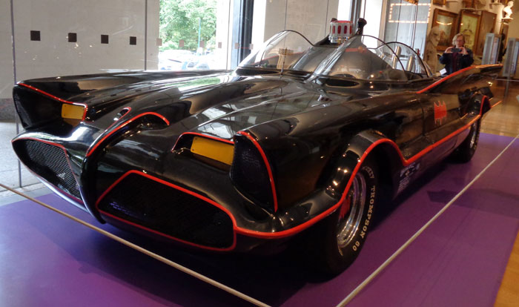
BATMOBILE, 1966.

Same bat time, same bat station, different bat channel: As part of Super Week, both Comic Conat the Javits Center and the New York Historical Society’s exhibit, Superheroes in Gotham, open later this week on Manhattan’s West Side. But even though the Javits Center regularly hosts major auto shows, it’s the museum that features a working Batmobile from 1966. The show is on view from Oct. 9 through Feb. 21, 2016.
NYHS’s multimedia extravaganza traces the rapid rise of comic books since the 1930s and their larger-than-life characters, namely Superman, Batman, Wonder Woman, Captain America, Spider-Man and Iron Man. “Superheroes were inspired by the hardships and experiences of urban life,” said Louise Mirrer, NYHS president and CEO, during Wednesday’s press preview. New York’s elevated lines, rooftops and back alleys served as perfect backdrops for the action.
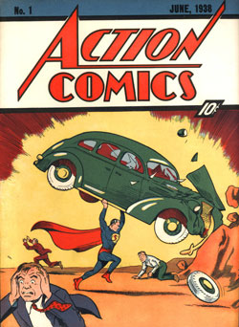
JERRY SIEGEL (WRITER) AND JOE SHUSTER (ARTIST), ACTION COMICS (NO. 1, JUNE 1938). PUBLISHED BY DETECTIVE COMICS, INC., NEW YORK. COURTESY OF METROPOLISCOMICS.COM.

The show follows these legends’ transition from print to radio to television, Hollywood and Broadway. Illustrated cards outline each character’s origins, traits, alter egos and the devices they use. Superman was the pioneer, since he was the first superhero character with a comic book, fanzine, radio show, animated cartoon and TV series. The exhibit concludes with a costume from Broadway’s Spider-Man Turn Off the Dark.
The dynamics of fandom and its cultural impact represents another key theme. DC Comics and Marvel Comics used to print fan letters and comments from comic book creators, an early form of social networking. New York’s annual Comic Con event, which started as a small-scale convention in 1964, has grown exponentially ever since.
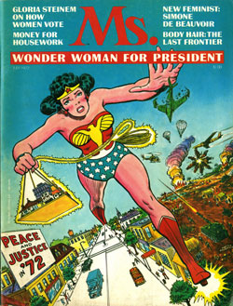
MS. MAGAZINE (ISSUE NO. 1), 1972. NEW-YORK HISTORICAL SOCIETY. COURTESY AND © MS. MAGAZINE

In curating the exhibit, Debra Schmidt Bach, NYHS’s associate curator of Decorative Arts, and Nina Nazionale, director of Library operations, assembled a treasure trove of memorabilia. These provide context to the history, such as the characters’ patriotic support during wartime. Among the artifacts: drawings, posters, scripts, video clips, costumes and action figures.
The star attraction is the vintage Batmobile in the lobby, which arrived overnight on Monday. Among other highlights are a bright red bat phone, the Penguin’s umbrella and Catwoman’s costume. Wonder Woman graces the cover of Ms. Magazine’s first issue, since she was a favorite character of its co-founder, Gloria Steinem.
These superheroes also inspired local artists, cartoonists and magazine illustrators. Mort Gerberg, a longtime New Yorker cartoonist, incorporated Batman references into his sketches. In one notable cartoon, Robin shows up as a job candidate and the interviewer asks, “Do you have any references besides Batman?”
A superheroes newsstand features comic books from around the world, (The French cover headline: “Quel Monstre Menace Batman?”) It’s clear from this display that the characters quickly evolved from being local and national to global sensations.
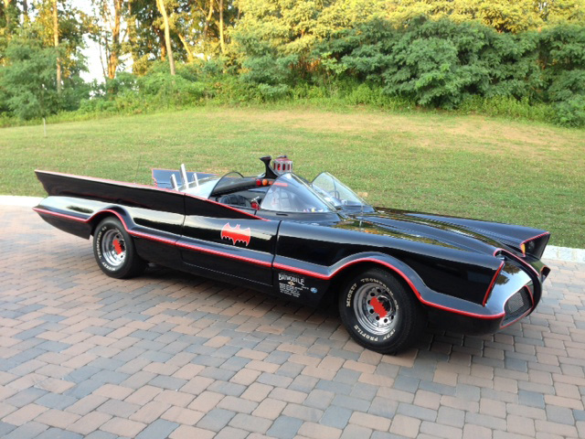
GEORGE BARRIS KUSTOM CITY, BATMOBILE, NO. 3, 1966. THE MORRIS FAMILY COLLECTION

